Accela Ad hoc Reporting Form Designer - Help

**Lydia Lim’s cheatsheet – For internal Accela use only**

Turn on *Navigation Pane* to see table of contents (Menu Bar > View > Navigation Pane)

AHR = Ad Hoc Reporting

# Overview

* Form Designer was released in AA 7.3
* Form Designer is an integrated feature of Accela Ad Hoc Reporting. It is accessed using the “Design Form” button on the AHR **Fields** tab.

## Success Community How-To Articles

* **Working with the Form Layout Tool:** (Detailed usage help – added 8/24/2015)
  + <https://accela.force.com/success/articles/Documentation/idb52260fa-3858-4a6b-a692-a6c42897c668rev8-0-0>
  + Linked from Article 000012011: **Ad Hoc Reports**

## Summary of Form Designer features in AA 7.3 Release Notes

* See Accela Automation 7.3 Release Notes.pdf
* See **Ad Hoc Report Enhancements (13ACC-01013)** on page 71
* Describes layout functionality available, and known issues.

## Izenda (vendor) Info on Form Designer

* <http://www.izenda.com/Site/Pages/Forms.aspx>
* <http://www.izenda.com/Site/KB/FAQ/Izenda-Forms>

# System Requirements

## Browser Version

Internet Explorer 9.0 and above



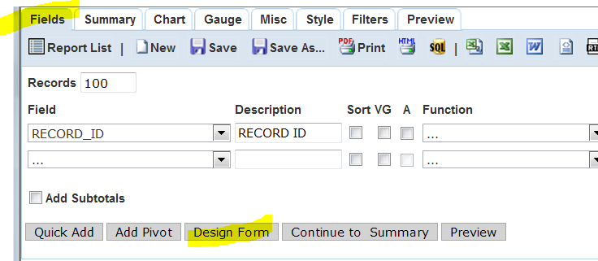

# ASIT

* Can be displayed in Form as table.
* Two ways of doing this:
  + Using [repeater] tag - Better
  + Using subreport - Works, but has drawbacks:
    - Global logo appears when subreport is rendered - so that logo appears twice in output
    - Large space inserted before subreport even when global logo is replaced by blank logo image.
* Use Template to bring ASIT columns into Field dropdown.
* See IMPREF agency in Support: Testing

# Data

## ~~Fields With #~~

* ~~Fields ending with # don't appear in list of fields. They are still in view, however:  
  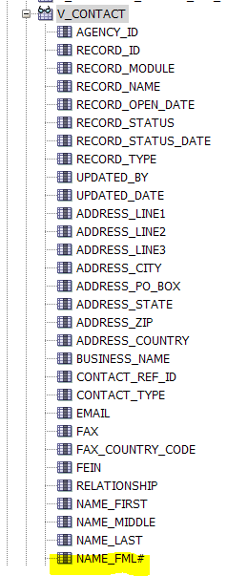~~

## ~~Joins~~

* ~~Tool automatically joins tables by RECORD_ID~~

# Layout Help

## Field Tags

* Not case sensitive
* Field doesn't need to be in Fields List (Fields tab) to be inserted in the Layout.
* Can use Field's "Description" in the tag instead of the original field name
  + Example:  
    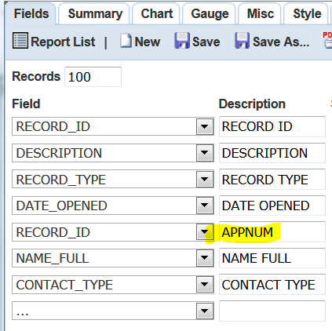  
      
    In Form Design:  
      
    

## Field Name Duplicated

* If two different views have the same field name, and the report needs to reference both separately, alias one of them using the "Description" column in the ***Fields*** tab. Use the Description as in the Field tag in the Form Design instead.
* See Field Tags above.

## Image, Insert

* Specify external URL or server File Directory path.
* File Directory path must be on Ad hoc Reporting Server
  + Per Engineering, Salesforce case 13ACC-10105
  + (Tested local path on C: drive - didn't work)
* To insert image, click *Image* icon at end of Form Designer tool bar:  
  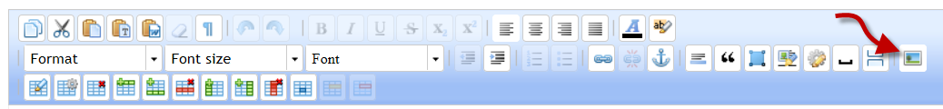
* Image pop-up appears. Enter Image URL and other info, e.g.:  
  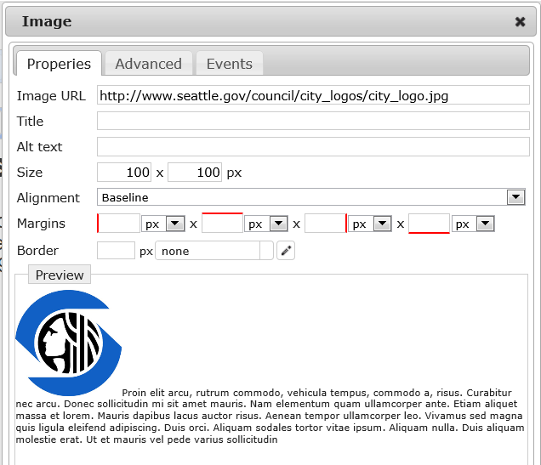
* ~~Note that image won't render in PDF, but will render in Word. See~~ **~~Issues / Bugs~~** ~~section below.~~ Fixed in AA 7.3.3.
* To edit image settings, select image in layout, then click Image icon in tool bar.

## Letterhead as Common Resource (Shared Subreport)

* It is possible to create a subreport that contains a Letterhead (image and text).
* See Layout Help > Subreport below for detailed steps.
* In Letterhead report:
  + Must use view that contains RECORD_ID (not V_STANDARD_CHOICE).
    - If V_STANDARD_CHOICE is used as Data Source instead, when you add the report to the main report as a subreport and Preview, the following message appears in the output: "Filters Required for Embedded Subreports"  
      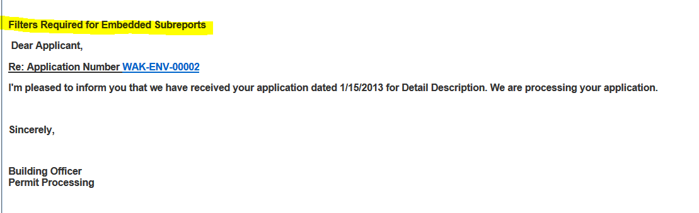
  + Add RECORD_ID as filter
  + Add RECORD_ID as drill-down key
  + Form Design contains hardcoded text only (no fields). Cannot pull from Standard Choices (see above).
  + See sample in IMPREF agency in Support: Testing > Letterhead_Subrpt
* Problems:
  + When main report is output to PDF, large empty space inserted above letterhead.
  + Logo won't render when output to PDF - Known bug Salesforce case 13ACC-10105
    - Bug fixed in AA 7.3.3. Verified in Support on 10/24/2014.
    - Logo renders OK when output to Word
  + Example of logo that doesn't render in PDF:  
    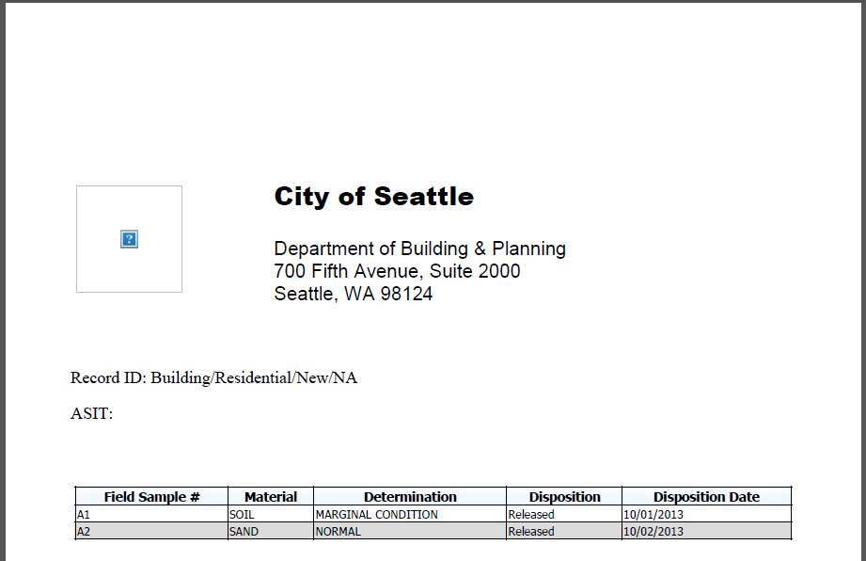
  + Example of fix (as of AA 7.3.3):  
    

## Page break, Insert

* Use this button near the end of the menu bar: 
* Only appears in PDF output
* Page breaks don't appear in Preview or in any output format but PDF.
* Problem: Blank page always appears at end, because tool inserts page break even after last row.

## Repeater Tag

* Where report needs to show group and detail, use **[repeater**] tag.
* Enclose "Detail" fields within paired **[repeater]** and **[/repeater]** tags.
* Tool will automatically group by all fields used in layout but outside [repeater] tags, and repeat the layout for each row in this group.
  + A row in the group consists of the unique combination of all the grouped fields (i.e., all fields in layout outside repeater tags).
  + If a field is in the Fields List but not used in the layout, it is not used in grouping.
* [repeater] tag and end tag can be enclosed in javascript comment <!-- --> marks so they don't appear in layout pane, but do work as repeaters.  
  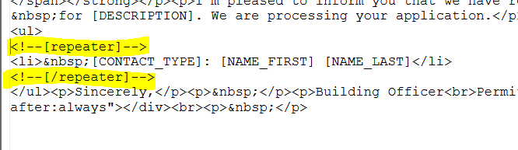
* Example:  
  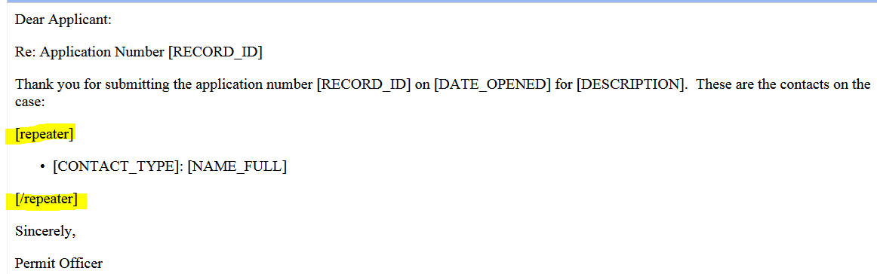

OUTPUT (repeating "detail" rows are highlighted)  
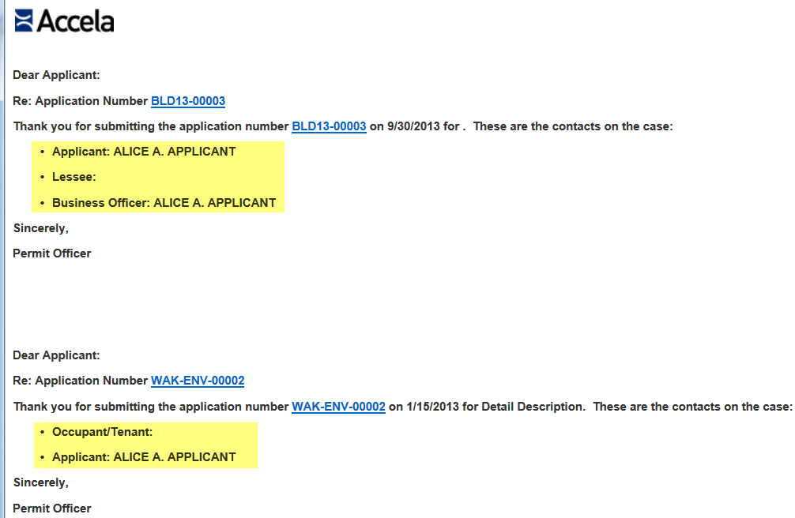

## Repeating of Layout

* Entire layout repeats for each row returned by query, unless repeater tag is used to create Grouping and Detail.

## Subreport, Embedding

* Subreport can be embedded into a report.
  + Subreport can pull data from standard fields or ASI / ASIT.
  + Multiple subreports can be embedded in Form.
  + Subreport can be tabular report or another form.

### Steps

1. **Create report to be used as subreport.**
   1. Add filter by RECORD_ID
   2. Add RECORD_ID as Drill-down Key. Misc tab > Drill-down Key.
   3. Don't add Form Design.
   4. Remove Date/Time and Page # from header: In Style Table, uncheck these items:  
      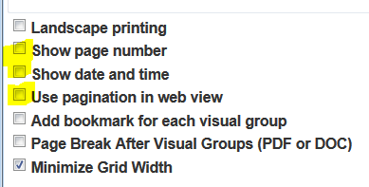
2. **Create report that will contain the above subreport.**
   1. In Form Designer, insert [[*Category\Report Name*]] where subreport should appear. Example:  
      [[Testing\ASIT_Subrpt]]  
      
   2. Don't change the Advanced Settings for the RECORD_ID field to specify a subreport.  
      DON'T do this:

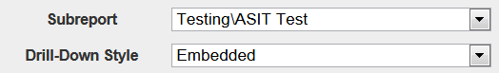

* 1. The RECORD_ID field doesn't need to be in the Form Design for the subreport to work.

1. **Note**: Main report output contains global logo in BOTH main report and in subreport. Example:  
   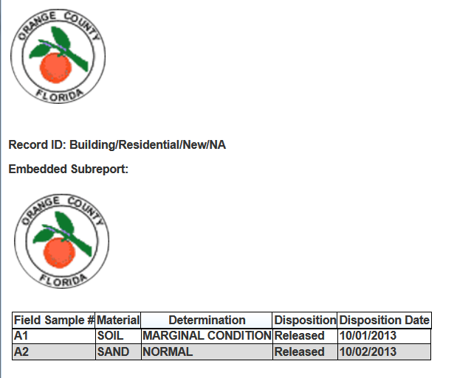
   1. **Workaround** to remove global logo, uploaded a white spacer image in PNG format instead. This means the global logo won't appear in ANY report, whether regular tabular reports, or Form reports.
   2. See Ad hoc Reporting - Usage Help.docx > Output > Logo (Global) for info about changing global logo.
2. See IMPREF agency on av.supp.accela.com:
   1. **Testing\Report w Embedded Subreport**
   2. **Testing\Letterhead_Subrpt**
   3. **Testing\Fees_Subrpt**
   4. **Testing\ASIT_Subrpt - deleted??**

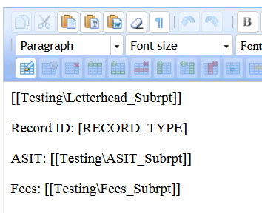

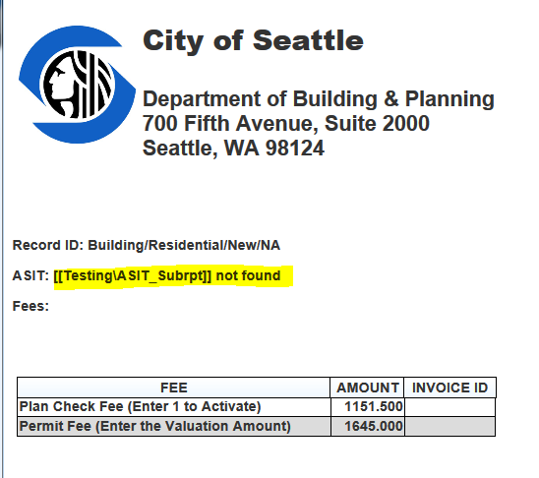

## Table

### Adding to Layout

* HTML Table <Table> can be inserted using Table button 
* Form Designer always inserts it near top of the layout, regardless of where your cursor is when you insert the Table.
* Go to Source page to move <Table>….</Table> (i.e. tags and everything in between) to the correct position.

### Displaying separate table rows for each row returned by report query

* To repeat rows in HTML table for each result row, use [repeater] tag.
* For example, a permit displays Fee Details (multiple rows in tabular format) below the Permit (i.e. Record) information.
* HTML source code for Fee Details table:

<table style="border: 0px rgb(0, 0, 0); width: 800px; background-color: transparent;" rules="none">

<tbody>

<tr>

<td>&nbsp;Description</td>

<td>&nbsp;Total Fee</td>

<td>&nbsp;Paid</td>

<td>&nbsp;Outstanding</td>

</tr>

<!--[repeater]-->

<tr>

<td>&nbsp;[DESCRIPTION]</td>

<td>&nbsp;[AMOUNT]</td>

<td>&nbsp;[AMOUNT_PAID#]</td>

<td>&nbsp;[AMOUNT_DUE#]</td>

</tr>

<!--[/repeater]-->

</tbody>

</table>

* Notice the [repeater] opening and closing tags enclosing the 2nd row only. This row contains the field tags, and this row will repeat for each result row.
* Sample Form Output:  
  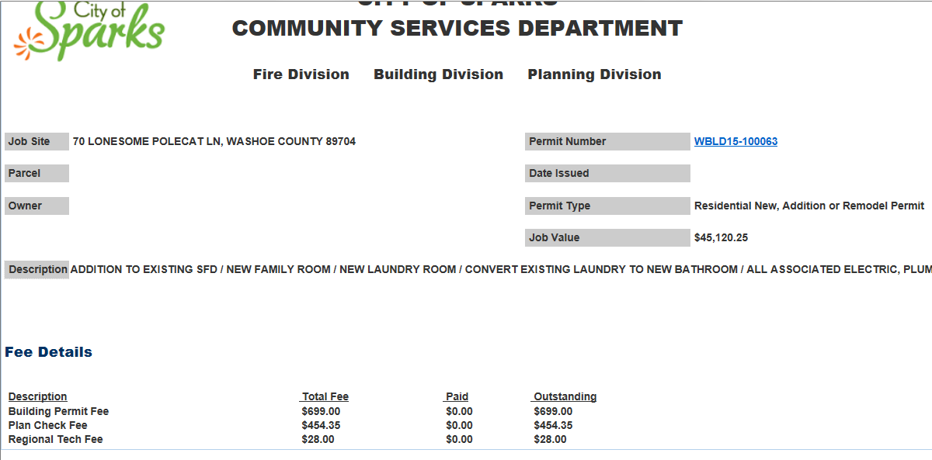

# Export formats

## PDF

* Use this button on menu bar in Preview: 
* Seems to work fine. Blank page is always added at end (?)
* Fonts, sizes, spacing in PDF differs from output in AHR preview. For example,

**Preview:**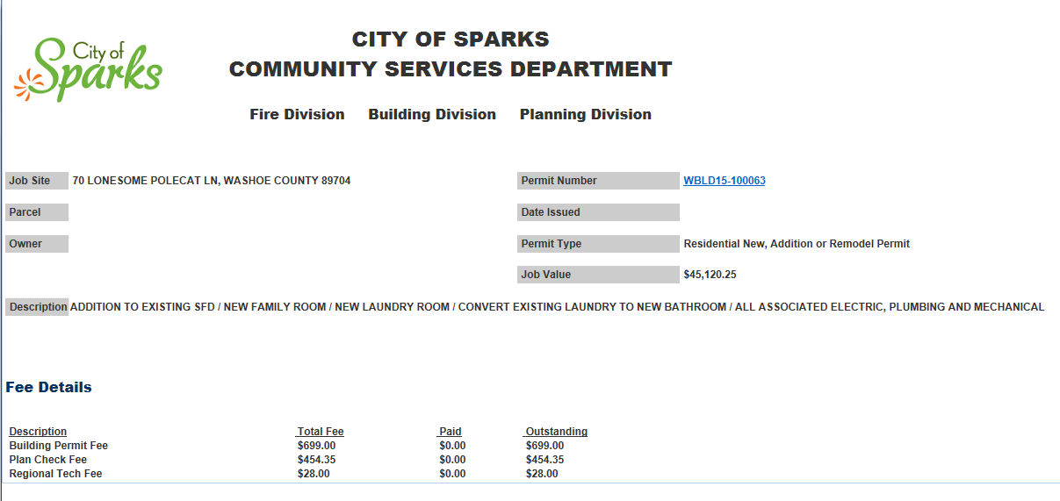

**PDF:**

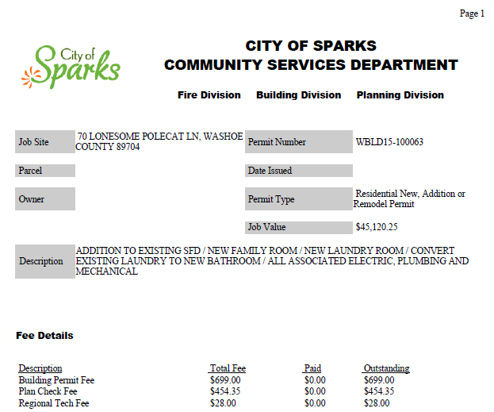

* ~~Image inserted in Form Designer as URL appears in Preview but won't export to PDF.~~ – Fixed by Engineering
* **GIF renders in PDF with borders (PNG spacer didn't render with borders):**  
  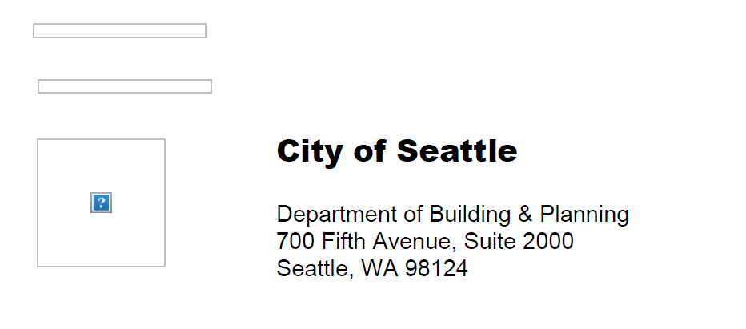

## RTF

* Use this button on menu bar in Preview: 
* Doesn't export as letter. Exports in tabular format instead (??)
* Sample letter exported to RTF:  
  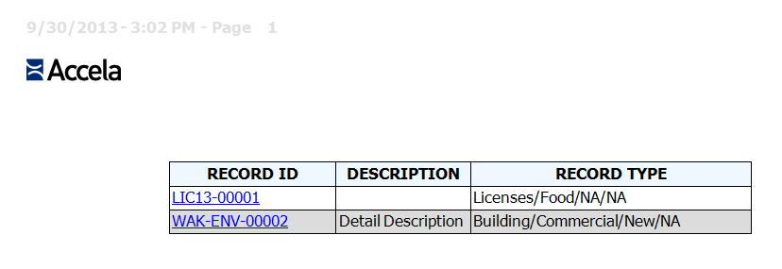

## Microsoft Word

* Use this button on menu bar in Preview: 
* Retains formatting, but no Page Break.

## Microsoft Excel (MIME)

* Use this button on menu bar in Preview: 
* Retains formatting, but no Page Break.

## CSV

* Use this button on menu bar in Preview: 
* Data only, no formatting. Eg:  
  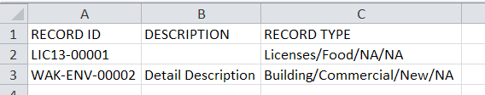

# Issues / Bugs

## Image doesn't export to PDF

* Image appears in preview and exports to Word, but not to PDF:  
  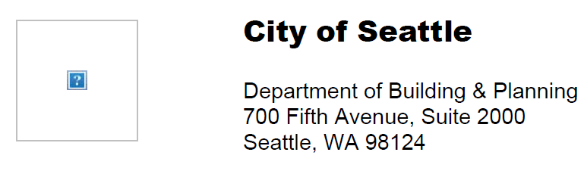
* Opened SF case 13ACC-10105 on 10/2/13. Escalated to Brian Wienke on 10/18/13. Brian said this was a known problem. Asked Brian to provide fix ETA.
* Fixed in AA 7.3.3

## Layout disappears with re As

* After doing a Save As, the entire layout disappeared - wiped out. Had to re-create.
* The old Layout is still retained in original report.
* Logged as bug in case 13ACC-10034 on 10/1/13.
* Engineering's answer: Cannot save Form Design using "Save As".
* **Workaround**: Copy HTML source code into Notepad. Do "Save As" of report in AHR, open Form Designer > Source, and paste HTML code in.
* Appears to be fixed a/o March 2015? (tested at BPT site)

## Logo always appears at beginning of Preview

* Documented Issue: See AA 7.3 Release Notes, page 73:  
  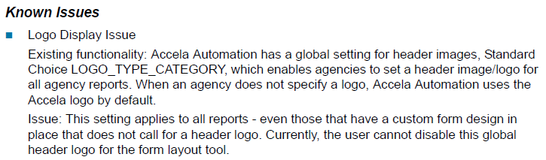
* Workaround 1:
  + Remove global logo altogether by replacing it with an "empty" PNG image file. Use .PNG (not .JPG or .GIF which render in PDF with border).
* Workaround 2
  + Insert a page break at the top of the layout.
  + The first page of the report output will be blank and only contain the global logo.
  + All subsequent page(s) contain the desired layout without the global logo.
    - It is possible to display a different "local" logo on all pages of report. Insert it into the layout anywhere after the page break.

## Page Break inserts empty last page

* When page break is used to separate multiple letters generated as a batch, tool inserts a blank page at the end of the PDF output, because page break is performed even after last row of resultset.

## Preview not refreshed with layout edits

* After saving report then returning to edit it, edits to layout don't appear in preview though they are saved in Form Designer (and appear when returning to Form Designer).

## Update to subreport not reflected when main report is run

* Close AHR and reopen to see refreshed subreport when main report is run.

## Save As (form) doesn't work

13ACC-10034 - this is izenda limitation

See workaround

## If subreport referenced by Form Design is missing from the reports list, AHR will hang when you run the main report from the Reports List.

* Main report will run OK from the Preview button in the design tabs, and show an error message within output about missing subreport:



Prepared by Lydia Lim, Accela Services

Updated 10/24/2014